**Running Selenium Script on Edge Browser:**

For running scripts on Edge we need microsoftwebdriver.exe. Go to google and search for microsoftwebdriver.exe. You will see the “WebDriver – Microsoft Edge Development” as the first result.

Click on it and you will see different versions for the edge driver.

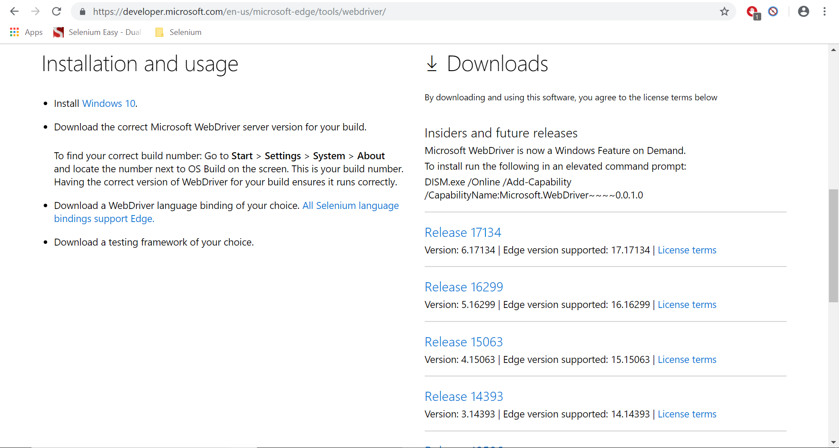

You need to find out which version you have to download. This depends on your windows 10 system version you are using. To find out which version you are using go to search bar and type “settings” and open settings.

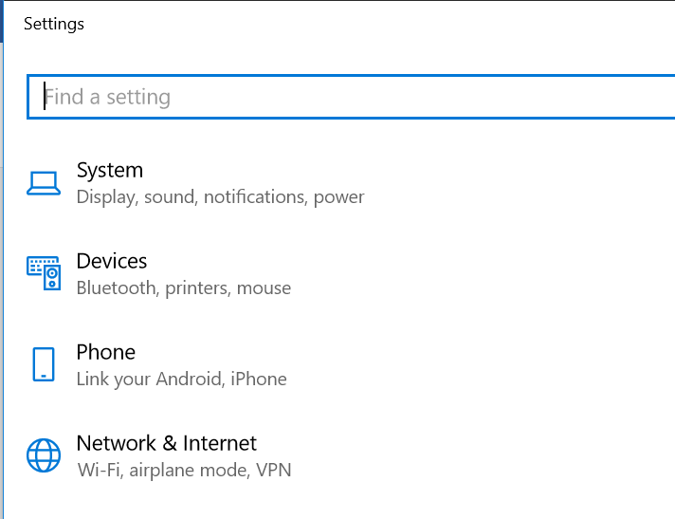

Go to System and then go to About.

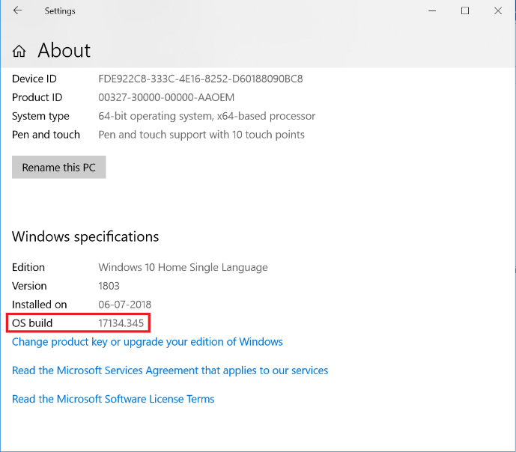

You will see OS build. In my case it is 17134.345. So, I download the Release 17134.

Once you download the driver set the system property for this driver exe file.

Edge Driver:

System.setProperty(“webdriver.edge.driver”,”Path to microsoftwebdriver”);

**package** Selenium;

**import** org.openqa.selenium.WebDriver;

**import** org.openqa.selenium.edge.EdgeDriver;

**public** **class** EdgeBrowser {

**public** **static** **void** main(String[] args) {

System.*setProperty*("webdriver.edge.driver", "C:\\BrowserDrivers\\microsoftwebdriver.exe");

WebDriver driver = **new** EdgeDriver();

driver.get("http://www.rediff.com");

}

}

The above will open the edge browser and open Rediff.com